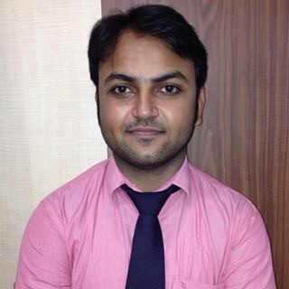**Curriculum Vitae**

**RAVINDRA PANWAR +91-8376818886**

**skype : - ravikp87 e-mail : -rkr2511@yahoo.com**

**PROFILE**

More than 4 years of enriching experience in customer interaction and relationship for different roles in Marketing and Sales. Always taking initiative and leading from front to help organize myself in order meet and fulfill the individual as well as team goals set to improve my company as an organization in a competitive Indian market. Looking forward to continue my career with an organization that will utilize my experience and skills to benefit the mutual growth and success.

**EXPERIENCE**

I have worked with Axis Bank Ltd since August 2012 to August 2014 and I was appointed as an Officer Sales since March 2013 for excellent performance.

Have vast experience in challenging role as a Bank representative for sales and marketing role.

The role is very much challenging as the growth of the Banking System has led the market to new dimension of marketing in order to get more business and tough competition in sales as the customer is more aware to new products and services.

I would say it’s rather tough to find a business which is growing with the pace of Axis Bank and to keep it growing at the same pace, fresh approach; market sense and better communication skills are required.

* Got recognition for excellent sales person many times.
* Achieved goals for the most challenging products with full customer satisfaction and helped improve the customer satisfaction index.

**PAST EXPERIENCES**

* Worked in Hirason Agency from January 2011 to May 2012 which pioneers in Logistics & Transport as a Sales Executive.
* Was a Sales Executive In Kataria Motors (Maruti Suzuki Dealership) from July 2009 to December 2010.

**SKILL SET**

* Office automation tools like Microsoft Office Suite, Open Office.
* Operating Systems Microsoft Windows 7 and XP.
* Moderate level speaker and good in communication in English and Hindi languages.

**ACADEMIC**

* B. COM GUJARAT UNIVERSITY 2011
* 12TH G.S.E.B. 2006
* 10TH G.S.E.B. 2004

**PERSONAL DETAILS**

Date of Birth **:** 25th November 1987

Gender **:** Male

Marital Status **:** Single

Nationality **:** Indian

Languages **:** Moderate in English, Proficient in Hindi& Gujarati

Father’s Name **:** Lt. Shri Karansingh Panwar

Address : Shalimar Bagh, Delhi - 110088

Personal Traits **:** Good level of maturity, leadership abilities, dynamic, pragmatic and in addition possess excellent problem solving skills.

Passport Details : Indian

K5859866

Extra-Curricular  **:** Actively participating in cultural and organizational events, Listening Music

**DECLARATION**

I certify that the statements made by me are true, complete and correct to the best of my knowledge and belief.

**(RAVINDRA PANWAR)**